[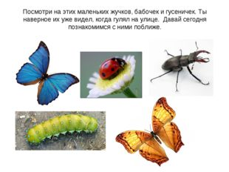](https://ds03.infourok.ru/uploads/ex/0641/00021598-435a1cf7/img1.jpg)

.

[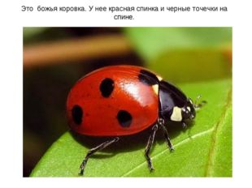](https://ds03.infourok.ru/uploads/ex/0641/00021598-435a1cf7/img2.jpg)

[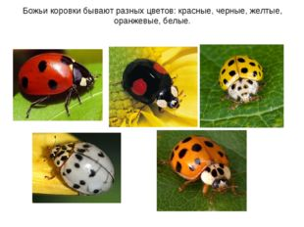](https://ds03.infourok.ru/uploads/ex/0641/00021598-435a1cf7/img3.jpg)

[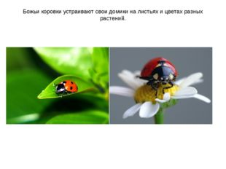](https://ds03.infourok.ru/uploads/ex/0641/00021598-435a1cf7/img4.jpg)

[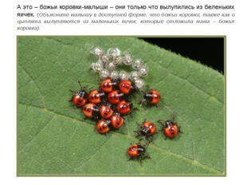](https://ds03.infourok.ru/uploads/ex/0641/00021598-435a1cf7/img5.jpg)

[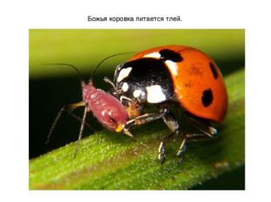](https://ds03.infourok.ru/uploads/ex/0641/00021598-435a1cf7/img6.jpg)

[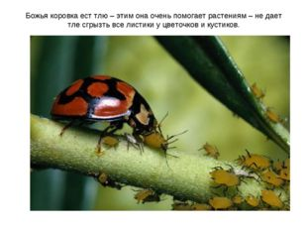](https://ds03.infourok.ru/uploads/ex/0641/00021598-435a1cf7/img8.jpg)

[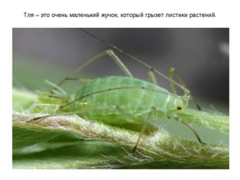](https://ds03.infourok.ru/uploads/ex/0641/00021598-435a1cf7/img7.jpg) Божья коровка ест тлю – этим она очень помогает растениям – не дает тле сгрызть все листики у цветочков и кустиков.

[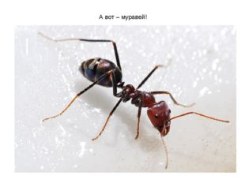](https://ds03.infourok.ru/uploads/ex/0641/00021598-435a1cf7/img9.jpg)

[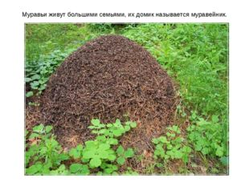](https://ds03.infourok.ru/uploads/ex/0641/00021598-435a1cf7/img10.jpg)

.

[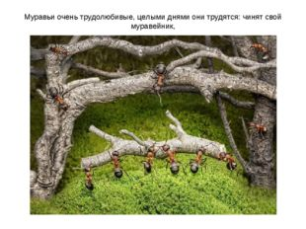](https://ds03.infourok.ru/uploads/ex/0641/00021598-435a1cf7/img11.jpg)

[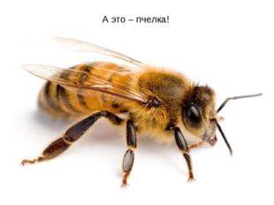](https://ds03.infourok.ru/uploads/ex/0641/00021598-435a1cf7/img14.jpg)

16 слайд[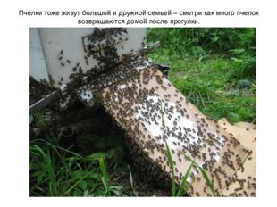](https://ds03.infourok.ru/uploads/ex/0641/00021598-435a1cf7/img15.jpg)

[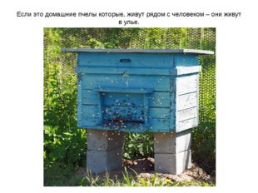](https://ds03.infourok.ru/uploads/ex/0641/00021598-435a1cf7/img16.jpg)

[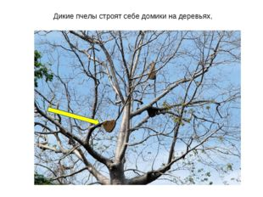](https://ds03.infourok.ru/uploads/ex/0641/00021598-435a1cf7/img17.jpg)

[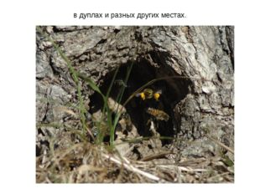](https://ds03.infourok.ru/uploads/ex/0641/00021598-435a1cf7/img18.jpg)

[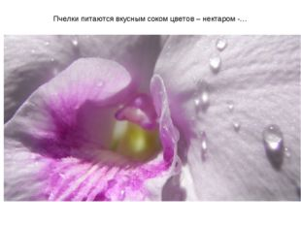](https://ds03.infourok.ru/uploads/ex/0641/00021598-435a1cf7/img19.jpg)

[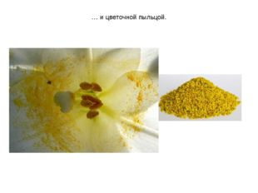](https://ds03.infourok.ru/uploads/ex/0641/00021598-435a1cf7/img20.jpg)

[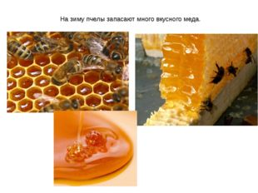](https://ds03.infourok.ru/uploads/ex/0641/00021598-435a1cf7/img21.jpg)

[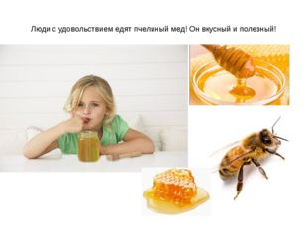](https://ds03.infourok.ru/uploads/ex/0641/00021598-435a1cf7/img22.jpg)

[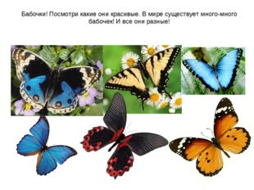](https://ds03.infourok.ru/uploads/ex/0641/00021598-435a1cf7/img23.jpg)

[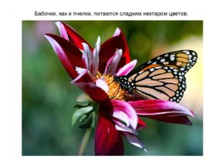](https://ds03.infourok.ru/uploads/ex/0641/00021598-435a1cf7/img24.jpg)

[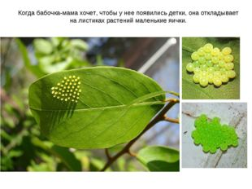](https://ds03.infourok.ru/uploads/ex/0641/00021598-435a1cf7/img25.jpg)

[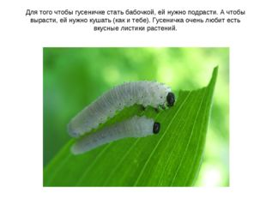](https://ds03.infourok.ru/uploads/ex/0641/00021598-435a1cf7/img27.jpg)[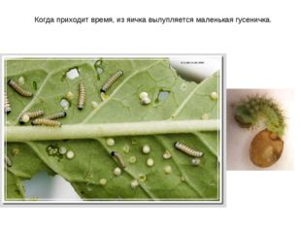](https://ds03.infourok.ru/uploads/ex/0641/00021598-435a1cf7/img26.jpg)

[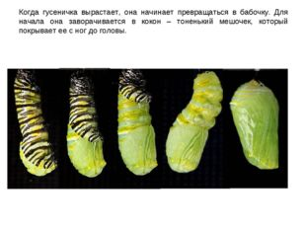](https://ds03.infourok.ru/uploads/ex/0641/00021598-435a1cf7/img29.jpg)

[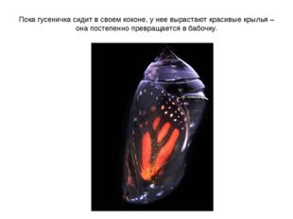](https://ds03.infourok.ru/uploads/ex/0641/00021598-435a1cf7/img30.jpg)

[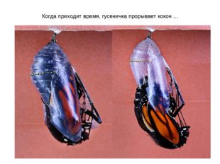](https://ds03.infourok.ru/uploads/ex/0641/00021598-435a1cf7/img31.jpg)

[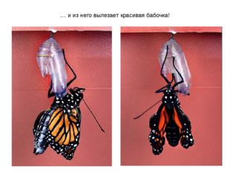](https://ds03.infourok.ru/uploads/ex/0641/00021598-435a1cf7/img32.jpg)

[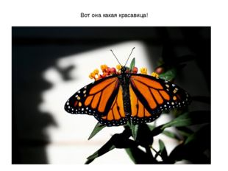](https://ds03.infourok.ru/uploads/ex/0641/00021598-435a1cf7/img33.jpg)

[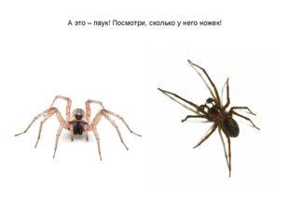](https://ds03.infourok.ru/uploads/ex/0641/00021598-435a1cf7/img34.jpg)

[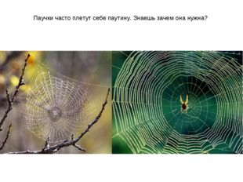](https://ds03.infourok.ru/uploads/ex/0641/00021598-435a1cf7/img35.jpg)

[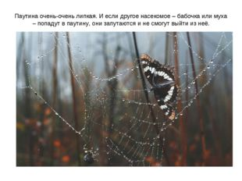](https://ds03.infourok.ru/uploads/ex/0641/00021598-435a1cf7/img36.jpg)

ё.

[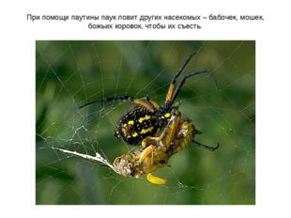](https://ds03.infourok.ru/uploads/ex/0641/00021598-435a1cf7/img37.jpg)

[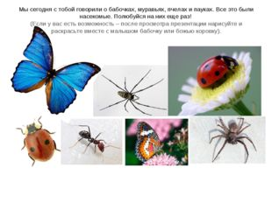](https://ds03.infourok.ru/uploads/ex/0641/00021598-435a1cf7/img38.jpg)